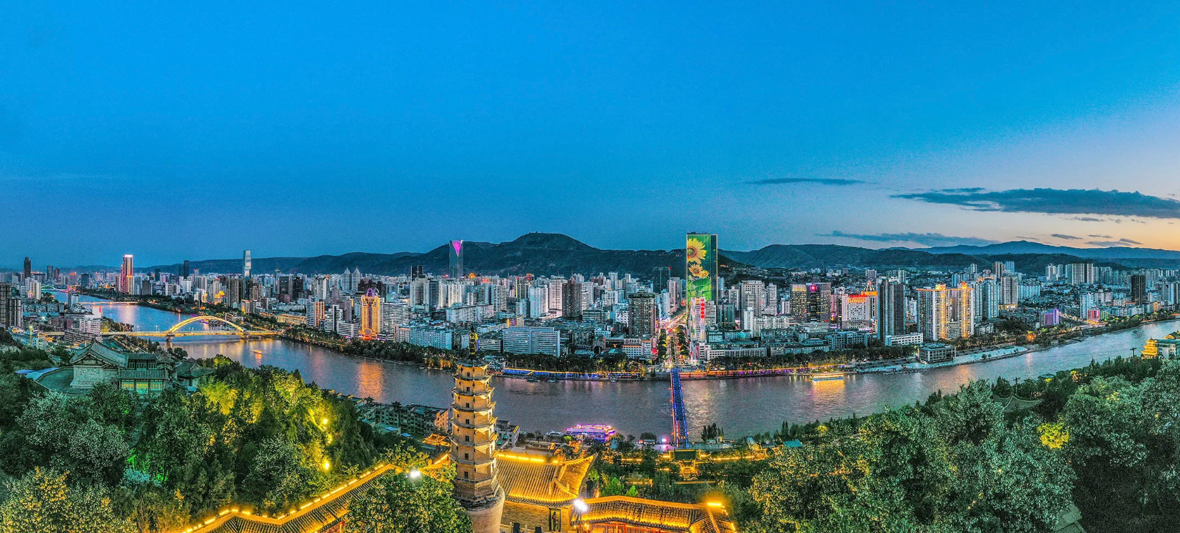

**Call for Papers**

Sponsored by the IEEE Robotics and Automation society, the 17th event of the ICIA conference series, the 2025 International Conference on Information Automation (ICIA 2025) will be held in Lanzhou, China, August 28-31, 2025, which offers a medium for researchers and practitioners to exchange and explore the issues and opportunities of electrical and computer engineering research and development from China and around the world. All submitted papers will be peer reviewed and accepted ICIA 2025 papers will be indexed by EI and included in IEEE Xplore. The ICIA 2025 conference promises to offer the participants a great experience with excellent technical and social programs. High quality papers reporting original research results and innovations in all aspects of information, automation, artificial intelligence, robotics, image processing, computer vision, DSP, BME and related areas as well as their applications are invited.

**Important Dates**

**June 15, 2025** Submission of full papers and organized session proposals

**July 10, 2025** Notification of paper acceptance

**July 25, 2025** Submission of final camera-ready papers

All submissions (including papers, proposals of invited sessions) should be completed via the website:

**http://www.icia2025.org/**

**ICIA 2025**

The 17th International Conference on Information and Automation

August 28-31 2025,Lanzhou, China

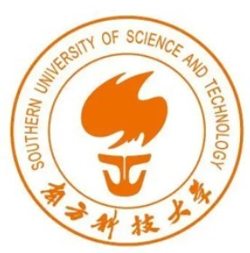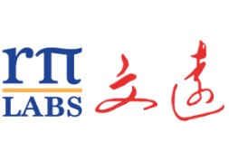

**Steering Committee**

DARWIN Caldwell, IIT

DUAN Guangren, SUSTech

LI Aili, Yuanhua Technology

MENG Max Q.-H., SUSTech/CUHK

QIAO Hong, CAS Inst. Automation

SUN Yu, Univ. of Toronto

ZHANG Hong, SUSTech

**General Chair**

GU Jason J., Dalhousie Univ.

**General Co-Chairs**

LI Yibin, Shandong Univ.

LIU Dikai, Univ. of Tech. Sydney

**Program Chair**

YUAN Yixuan, Chinese Univ. of HK

**Program Regional Co-Chairs**

DONG Lijing, Beijing Jiaotong Univ.

GU Dongbing, Univ. of Essex

GUAN Henry, Université Paris-Saclay

LUO Chaomin, Mississippi State Univ.

REN Hongliang, Chinese Univ. of HK

THANH Nho Do, Univ. of New South Wales

**Organizing Chair**

WANG Jiankun, SUSTech

**Organizing Co-Chairs**

CHEN Zhen, Zhejiang Univ.

LIU Jun, City Univ. of HK

LIU Peter X., Carleton Univ.

LIU Rong, Dalian Univ. of Tech.

QI Lin, Northeastern Univ.

WANG Jiaole, HIT Shenzhen

WANG Xin, Zhejiang Lab

YANG Simon X., Univ. of Guelph

ZHENG Minhua, Beijing Jiaotong Univ.

**Award Committee Chairs**

FAROOQ Umar, Univ. of Lahore

SONG Rui, Shandong Univ.

**Publication Chairs**

ASAD Mohammad, Dalhousie Univ.

SONG Shuang, HIT Shenzhen

**Local Arrangement Chair**

LIU Weirong, Lanzhou Univ. of Tech.